**Vi Editor - Assignments**

1.Invoke the vi editor with a filename (which is to be created) – **vi testFile.txt**

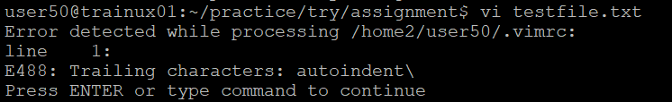

2. Type a few lines(at least 10) in the editor. Let one or more lines contain the words given below.

delhi mumbai chennai Mumbai

3. Save the file without exiting the editor - **:w**

4. Navigate quickly to the beginning – **gg**

& end of the file - **G**

5. Delete first two lines **– 1,2d**

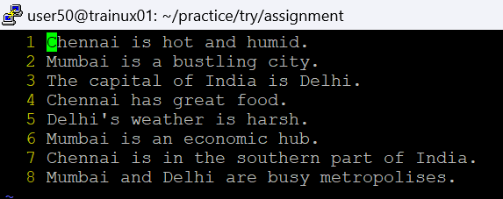

& copy it after the last line. **– 1,2t$**

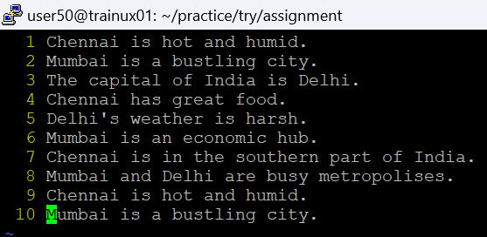

6. Now Copy the last two lines **- $-1,$y**

& paste them before the first line. **– 1t0**

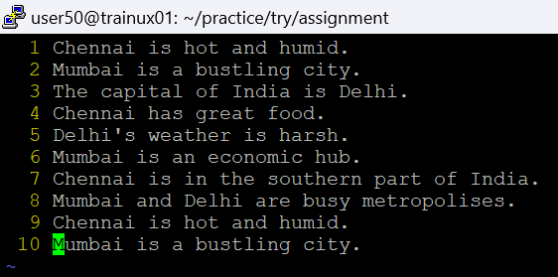

7. Combine last two lines of the file in a single line. **- $-1s/\n\\**

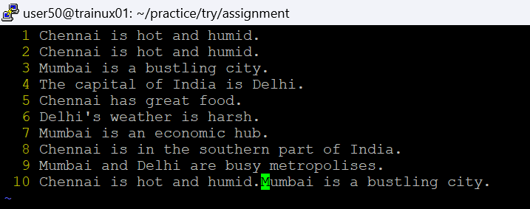

8. How will you insert a line before the first line? (Hint : Find such an option in the tutorial document) **- OThis is a new line above the first line.** (Write this in the first line of code in the insert mode)

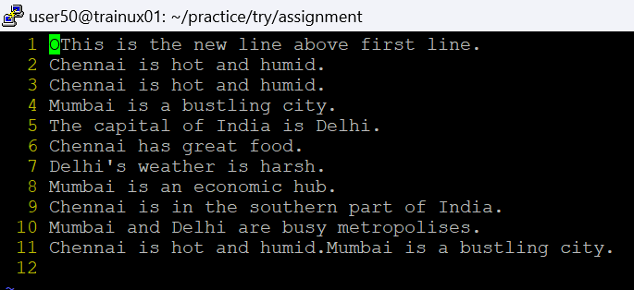

9. How will you paste a yanked buffer before the current line? **- :p**

10. Search the document for a string “delhi” - **/Delhi**

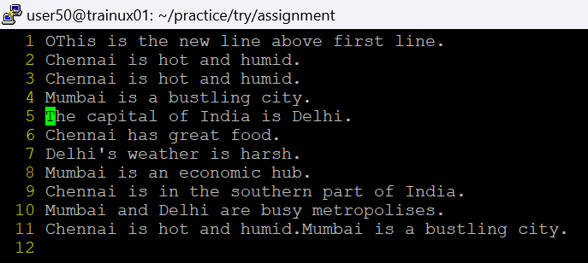

11. Replace a single occurrence of “delhi” with “Mumbai” **– s/Delhi/Mumbai**

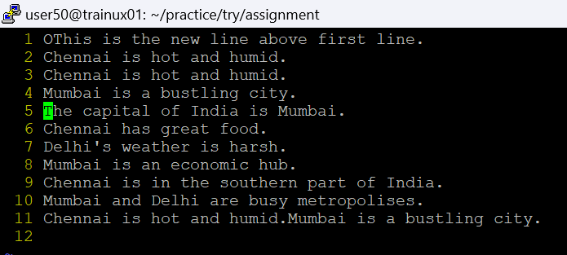

12. Replace all occurrences of “delhi” on a particular line with “Mumbai” using one command **– s/Delhi/Mumbai/g**

13. Replace “delhi” with “mumbai” for the entire document using one command. – s/Delhi/Mumbai/g

**– %s/Delhi/Mumbai/g**

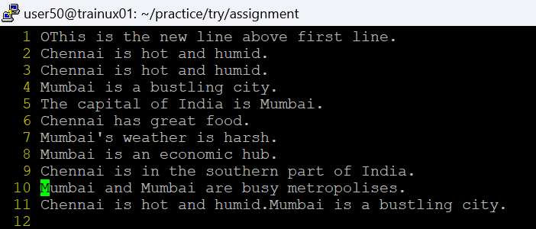

14. Replace all occurrences of “delhi” with “mumbai” for part of a document (e.g. line number 13 to 37). **– 3,8s/Delhi/Mumbai/g** (no changes as there is no more availability of Delhi in text)

15. Undo the above command **– u**

16. Replace only the first occurrence of “delhi” with “mumbai” in each line, for part of a document (e.g. line number 13 to 37). **– 3,8s/Delhi/Mumbai/**

17. Undo the above comment. **– u**

Redo it. **– ctrl+r**

Undo it again. **- u**

18. Replace all occurrences of “delhi” with “mumbai” for complete file interactively. - **----%s/Delhi/Mumbai/gc**

19. Search for a word backwards. Loop through all matches. **- ?Delhi**

20. Search for a word forwards. Loop through all matches **- /Delhi**

21. Join two lines together. **-J**

22. Enable line numbering **- set number**

and then disable it **- set nonumber**

23. Make the search case insensitive **- set ignorecase**

24. Delete 4 lines (and then paste them somewhere else) **– 2,5d**

**Paste - $t$**

25. What is the command to delete part of the line starting from the current cursor position? **- D**

26. What is the command to delete the current word? **- diw**